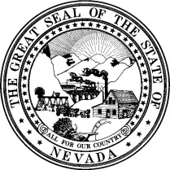
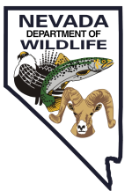
NEVADA DEPARTMENT OF WILDLIFE
NON-RESIDENT GUIDED ANTLERED MULE DEER HUNT

2019

POWER OF ATTORNEY

KNOW ALL MEN BY THESE PRESENTS, that the undersigned,

Last Name First Name M.I.

of the County of in the State of , being an applicant for the 2019 Non-Resident Guided Antlered Mule Deer Hunt drawing, does hereby make, constitute and appoint the following licensed Nevada Master Guide

Jurad Michael John

Last Name First Name M.I.

of the County of Humboldt in the State of Nevada , true and lawful attorney to act in the name, place and stead of the undersigned on an electronic application for the 2019 Non-Resident Guided Antlered Mule Deer Hunt, granting and giving unto said attorney in fact, full authority and power to do and perform any and all acts necessary specific to this application as full to all intents and purposes as the grantor might, or could, do if personally present, with full power of substitution. This authority expires at the close of the 2019 Non-Resident Guided Antlered Mule Deer Hunt season.

SIGNATURE

This instrument was acknowledged before me this day of , 20__________

by:
Printed Name of Above Person

Signature of Notary or Authorized Nevada Department of Wildlife Employee

Official Seal:

DEPARTMENT OFFICES

EASTERN NEVADA Elko 60 Youth Center Road, Elko, NV 89801 (775) 777-2300
Ely 1218 Alpha Street., Ely, NV 89301 (775) 289-1655
SOUTHERN NEVADA Las Vegas 4747 Vegas Drive, Las Vegas, NV 89108 (702) 486-5127
WESTERN NEVADA Reno 1100 Valley Road, Reno, NV 89512-2817 (775) 688-1506
Fallon 380 West B Street, Fallon, NV 89406 (775) 423-3171
Winnemucca 705 East Fourth Street, Winnemucca, NV 89445 (775) 623-6505

